

TED UNIVERSITY

Faculty of Engineering

Department of Computer Engineering

**CMPE 399 (or 499) – Summer Training I (or II) Report**

**STUDENT NAME:** (The name of the student)

**COMPANY NAME:** (The name of the company where the internship was held)

**SUPERVISOR:** (Title and name of the supervisor)

**INTERNSHIP DATES:** (From dd/mm/yyyy To dd/mm/yyyy)

**REPORT SUBMISSION DATE:**

*** This report template aims to help the students prepare their summer internship report for the CMPE 399/499 – Summer Practice I/II course. The students are required to follow the exact formatting of page setup, page, section, and subsection numbering, referencing, tables, and figures as given in this template. The grading of this report will be both over style and content. This report must be submitted according to the announced dates.

Table of Contents

2 INTRODUCTION 3

2.1 Overall Goal 3

2.2 Expected Learning Outcomes (LOs) 3

3 COMPANY INFORMATION 4

3.1 General 4

3.1.1 Historical background 4

3.1.2 Engineering Units 4

3.2 Products and Services 4

3.3 Work Environment 4

4 Assigned Tasks and Projects 5

4.1 Problem Definition 5

4.2 Knowledge Integration 5

4.2.1 Knowledge Integration with Course Work 5

4.2.2 Learned Tools and Technologies 5

4.2.3 Self Learning 5

4.3 Work Plan and Timeline 5

4.4 Implementation 6

4.4.1 Literature review and Data Collection 6

4.4.2 Implementation 6

4.5 Evaluation & Impact Analysis 6

5 Conclusions & Recommendations 7

6 References 8

# INTRODUCTION

The scope and goals of the summer practice should be summarized in this section. A summary of the work done, the motivation behind it, and the significance of the work in the overall project should be included in this section.

## Overall Goal

This part explains the overall goal with a simple, clear, brief, positive, and correctly written statement, that describes the "big-picture" idea of why the student is interested to have training, what he wants to focus on, and what he needs to accomplish.

## Expected Learning Outcomes (LOs)

This part states three or more correctly written learning outcomes that describe specific, measurable, and realistic achievements to accomplish during the training experience. They relate to the job, represent the job functions and duties, assist in professional growth and development, relate to the student's course of study or major, and help to reach the overall goal of student's training experience. Please be aware that this section should rely not only the written Learning Outcomes in Figure 1 on but also your own expectations from this summer practice.

metin, ekran görüntüsü, yazı tipi, siyah beyaz içeren bir resim

Yapay zeka tarafından oluşturulmuş içerik yanlış olabilir.

FIGURE 1: Course Learning Outcomes taken from course syllabus [1].

# COMPANY INFORMATION

This section includes general information about the company together with products and services it provides and the work environment that the student worked in.

## General

State the name and address of the company along with the name, background and contact information of the supervisor.

### Historical background

Write the focus areas, mission and short description of the company/ establishment history.

### Engineering Units

Engineering units are described in detail with their functions and organizational structure.

## Products and Services

Products and services of the company are summarized here.

## Work Environment

Physical conditions of the work environment, number of people working can be given here. As can be seen in Figure 2 there are 7 desks….

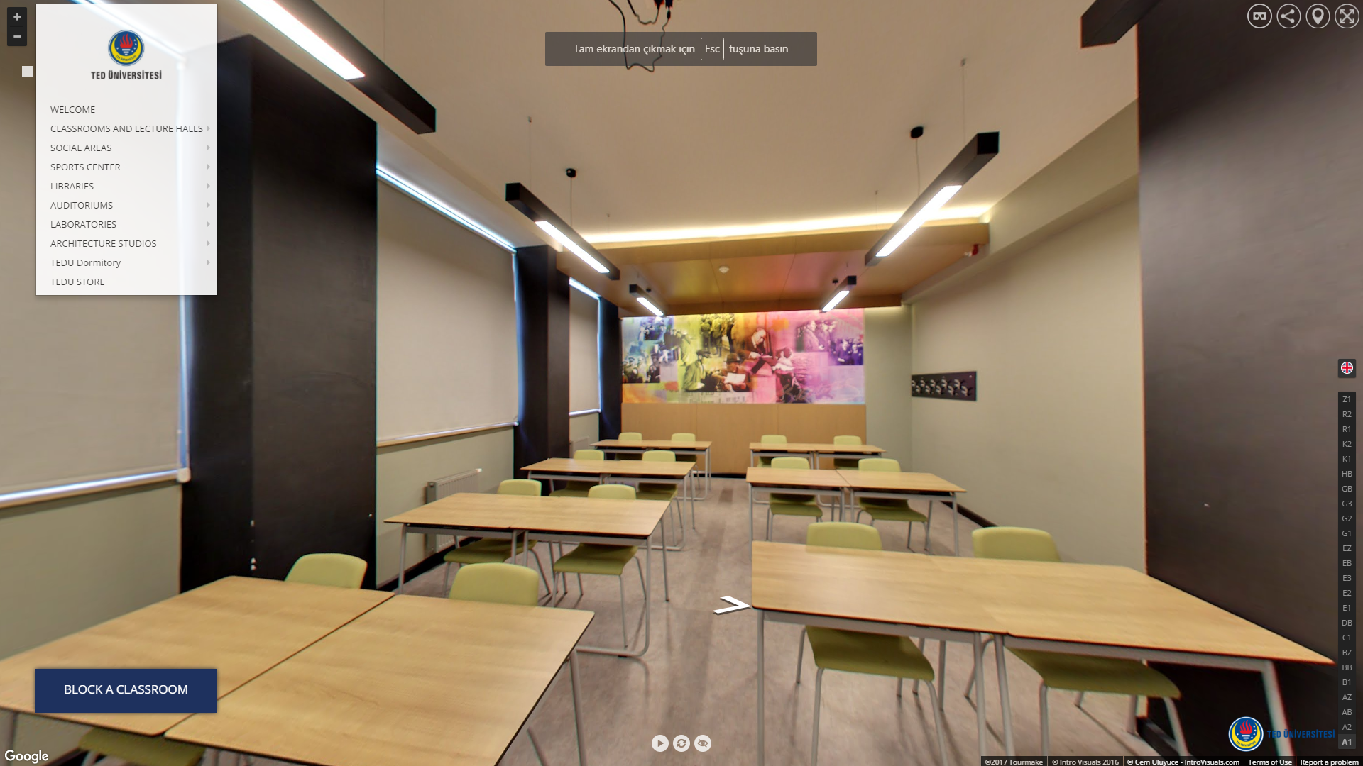

FIGURE 2: An example picture of the work environment.[1]

# Assigned Tasks and Projects

This section is the most important part of the report and must include details of the internship.

## Problem Definition

The nature of the activities carried out by the department(s) or unit(s) where the major part of the training experience took place, is clearly described in this section. Whether the function of the department is design, maintenance, R&D, project management, or anything else, the student should be able to relate it to the activities of the whole company / establishment.

## Knowledge Integration

This section explains the details of the knowledge integration with course work, learned tools and technologies together with the self learning of the student.

### Knowledge Integration with Course Work

Explain the relationship of the work done and the course work in this section.

### Learned Tools and Technologies

Explain the learned tools and technologies during the internship and how they are used.

### Self Learning

Explain the learning process during the internship, also include the references of these.

## Work Plan and Timeline

Explain your work plan and the tasks here. Tables must be referred properly. Table 1 shows a sample work plan but it might differ depending on your problem. Here you can also create the corresponding Gannt Chart for Table 1 and refer it. Figure 3 shows the Gannt chart of Table 1.

Task 1: Explain the task in detail, what you have accomplished, what outputs you produced,

Task 2: …

…

|  |  |  |  |
| --- | --- | --- | --- |
| **Task** | **Start** | **End** | **Duration** |
| Task 1 | dd.mm.yyyy | dd.mm.yyyy | 1 week |
| Task 2 | dd.mm.yyyy | dd.mm.yyyy | 1 week |
| Task 3 | dd.mm.yyyy | dd.mm.yyyy | 1 week |
| Task 4 | dd.mm.yyyy | dd.mm.yyyy | 1 week |

TABLE 1: A sample work plan.

metin, ekran görüntüsü, dikdörtgen, paralel içeren bir resim

Yapay zeka tarafından oluşturulmuş içerik yanlış olabilir.

FIGURE 3: Gannt Chart of the work plan given in Table 1.

## Implementation

This section discusses the actual implementation details together with corresponding literature review and data collection.

### Literature review and Data Collection

If the problem needed any literature review and/or data collection, explain the details in this part, do not forget to include the resources in the references section. Explain the data collection process and methods used.

### Implementation

Give details of any software/hardware implementation, do not include all of the code. Explain the key areas you focused and main components without giving any proprietary detail. (If you have an NDA - nondisclosure agreement, make sure that report gives information enough that you have worked on a problem. You can give a sample/test version before working on the actual solution.)

## Evaluation & Impact Analysis

Include your evaluation of your product and explain the impact that you have created during your internship work.

# Conclusions & Recommendations

Achievement of expected LOs , recommendations to enhance future training in this company together with ethical issues and finally the recommendations to enhance future training of TEDU enginering students are discussed in this section. Also you can include a comment in which you explain specifically what you have learned or understood about the economic, environmental, societal, and global impact of the engineering solutions in the projects developed at your company. You can either use separate subsections or you can mention all subtopics in a single section.

# References

When a reference, such as a book [1-2], handbook [3], report [4], journal [5], conference paper [6], or any other document is cited in the text, it should be properly listed in this References section. Use the [IEEE Citation Reference](https://ieeeauthorcenter.ieee.org/wp-content/uploads/IEEE-Reference-Guide.pdf) format.

|  |  |
| --- | --- |
| [1] | Course Syllabus – Learning Outcomes, Access date: 2025, August 22  https://www.tedu.edu.tr/sap-course-1429210918J. |
| [2] | K. Author, “Title of chapter in the book,” in *Title of His Published Book, x*th ed. City of Publisher, Country if not USA: Abbrev. of Publisher, year, ch. *x*, sec. *x*, pp. *xx–xx.* |
| [3] | TEDU Prospective Students. (Access date: 2017, June 15). Retrieved from <https://aday.tedu.edu.tr/tr/aday> |

1. Please refer to figures by their number (i.e., please see Figure 1 or “as explained in Fig. 1”). Do not refer to figures as "the figure below" or "the figure above." Refering to your figures is mandatory. Place the figure close as possible to the part of text referencing it. Centre the image.